Wednesday 6th January 2021

Dear Parents and Carers,

Here is an explanation of how you can access the Google Meet live check-in. As outlined in the new Home Learning timetable (now updated on the website) these live check-ins will take place at the following times. We have updated the times to allow any sibling groups to individually access their class meets:

10.30 – Hedgehogs
11.30 – Owls
11.45 – Badgers
12.00 – Foxes

- Please ensure that you are ready to log-in approximately 5 minutes before the Google Meet is due to start. Then, just before your Class Meet is scheduled to take place, please click on the following link on your Google Classroom portal (this can be found at the top of the Stream):
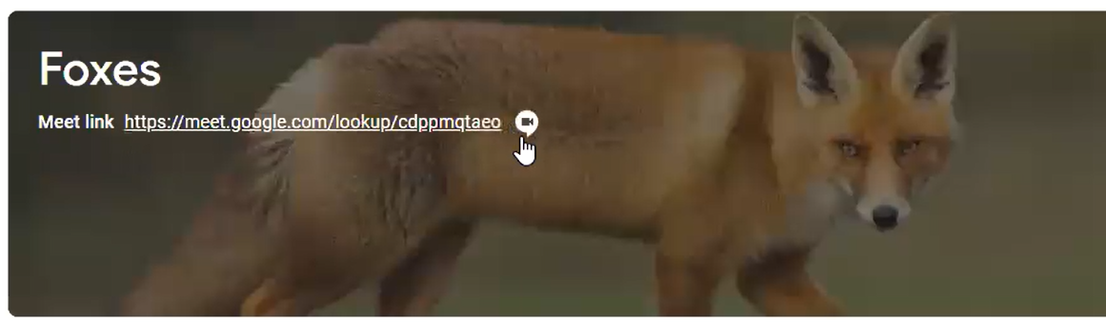

- Next, you will be asked to enable your camera and microphone. Press ‘Allow’:
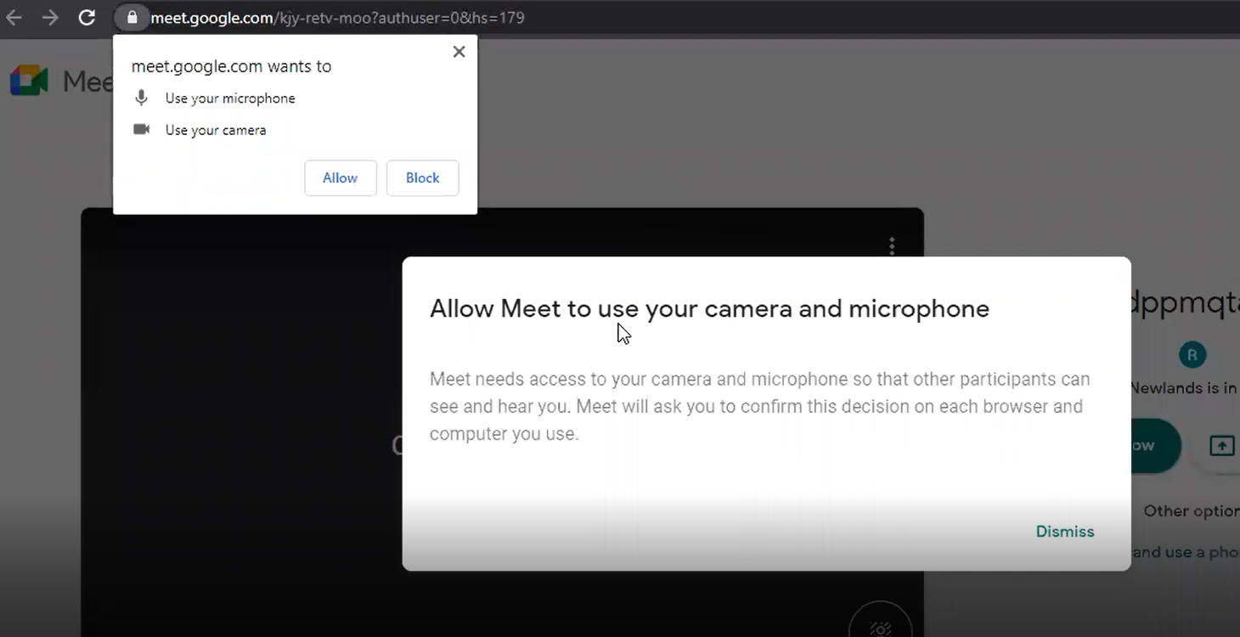
- Your class teacher will be there ready to greet you – please enter on mute.

We look forward to having this opportunity to meet up as classes (albeit virtually).

Kind regards,

Mr R Newlands
Head of School

