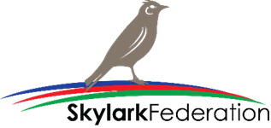

[](https://plumptonrobins.wordpress.com/)

**Barcombe Hamsey Plumpton**

**Skylark Federation**

STATEMENT OF BEHAVIOUR PRINCIPLES

**Reviewed and approved by FGB: 04.02.21**

**Review: Spring 2022**

Signed .................................. Chair of Governors Date ………………

Signed ................................. Executive Headteacher Date ………………

**STATEMENT OF BEHAVIOUR PRINCIPLES**

The Governors of Skylark Federation believe that high standards of behaviour lie at the heart of a successful school. A successful school enables all of its pupils to make the best possible progress in all aspects of school life and work, and enables its staff to be able to teach and promote good learning without undue interruption or harassment.

* Every pupil understands they have the right to feel safe, valued and respected, and learn free from the disruption of others
* All pupils, staff and visitors are free from any form of discrimination
* Staff and volunteers set an excellent example to pupils at all times
* Rewards, sanctions and reasonable force are used consistently by staff, in line with the behaviour policy
* The behaviour policy is understood by pupils and staff
* The exclusions policy explains that exclusions will only be used as a last resort, and outlines the processes involved in permanent and fixed-term exclusions
* Pupils are helped to take responsibility for their actions
* Families are involved in behaviour incidents to foster good relationships between the school and pupils’ home life

Expected standards of behaviour are clearly stated in the school’s Behaviour Policy. The school will treat all children fairly and apply this policy in a consistent way.