[](http://www.eastsussex.gov.uk/)



[](https://plumptonrobins.wordpress.com/)

**Barcombe Hamsey Plumpton**

**Skylark Federation**

**Hamsey Behaviour Policy**

**Reviewed and approved by FGB: 04.02.21**

**Review: Spring 2022**



**Behaviour Policy**

**What are our expectations of good behaviour?**

We expect good standards of behaviour and by this we refer to children who are: considerate; consistent; thoughtful; polite; respectful to **all** staff; good listeners who do not interrupt; conscientious; give maximum effort and stay on task; have pride in their work and their appearance; persevere; know how to share; walk through the school quietly and carefully; look after their belongings and those of others and of the school; set a good example for younger children; are ready to learn; do not distract others; respond to instructions appropriately; take part in school life enthusiastically.

**What do we mean by wrong choices?**

When children interrupt or call out; are rude to adults or other children; swear; distract others; act selfishly; show attention-seeking behaviour; have inappropriate physical contact ranging from the minor (for example, poking, nudging etc.) to the major (for example, punching, kicking etc.); tell tales as a means of undermining others; show meanness (for example, ostracising others, whispering campaigns, ‘winding up’ etc.); give verbal abuse/bad language; challenge adults; display a negative attitude to work or to school life; misuse internet applications; send inappropriate texts or make offensive telephone calls; show racist behaviour or other forms of intolerance.

**How do we lead by example?**

All teaching and support staff at Hamsey Community Primary School aim to foster good behaviour by providing good role models. To this end we recognise and reward good behaviour. We address the children by their names wherever possible, and we use PSHE lessons to discuss and promote strong, positive values and relationships and to develop self-awareness and self-discipline. We encourage the children to move around the school in a calm and orderly way. We seek to use calm, professional and positive language in all of our dealings with children. We seek to follow this policy consistently and fairly at all times.

**What is the role of the home/school partnership?**

As a school we encourage staff and parents/carers to work together to encourage all children at Hamsey Community Primary School to be happy and well-behaved. Where appropriate, we involve and consult with parents/carers in discussions over their children’s choices in school. We encourage parents/carers to let us know of any factors at home that might have an impact on a child’s behaviour at school (for example, separation of parents, bereavement, house move, redundancy or financial pressure). We encourage parents/carers to be aware of safe and reasonable internet and mobile phone practices, for example by ensuring that children do not engage in texting or ‘social networking’ unless they are of the requisite age and have the maturity to use the technology responsibly.

**What should parents/carers do if they have concerns about behaviour?**

As with all aspects of the children’s education and welfare at school, parents/carers who are concerned about any aspect of behaviour (from their children or others) are encouraged to follow these guidelines:

* Speak to the Class Teacher as soon as they are aware of the problem. Class Teachers are usually available at the end of the school day but appointments can be made at other times (through the School Office). In most cases, the Class Teacher will be able to resolve the matter.
* If the Class Teacher is not able to resolve the matter, the parent/carer should refer to the Executive Head Teacher or the Head of School who will review the matter and seek to resolve it at the earliest opportunity.
* If the parent/carer is still dissatisfied, a complaint can be made in writing and should be addressed to the Chair of Governors and delivered to the School Office.

Parents/carers are requested, respectfully, not to air grievances in other ways such as the informal discussion of issues at the school gate or through social networking sites or the circulation of texts, particularly when this might involve criticism (directly or indirectly) of named children, school staff or other parents/carers. Every member of our school community is entitled to have issues concerning them or complaints about them dealt with fairly and through the provided procedures.

**Learning Behaviours:**

At Hamsey School we are expecting children to show our learning behaviours throughout the school day. These are shown in all the classrooms and are regularly spoken about by all adults within the school. Our Behaviour Policy is based on positive rewards given for following our learning behaviours:

|  |  |  |  |  |
| --- | --- | --- | --- | --- |
| **Determination** | **Independence** | **Respect** | **Curiosity** | **Pride** |

**Class Dojo:**

Each class will use Class Dojo to reward and monitor learning behaviours during the school day. Points will be awarded for showing good learning behaviours and points may be removed if children make the wrong choices. All adults in the school will focus on rewarding good learning behaviours; this will encourage others to make the right choices, rather than focusing on children who are not showing the right learning behaviours.

The earned ‘Dojo Points’ will be collected by the Year 6 prefects and calculated for the four different house teams (Dragons, Unicorns, Griffins and Centaurs). If the whole school achieves the school ‘Dojo Goal’ the whole school will earn a reward at the end of term. The team with the most points at the end of the term gets to choose the whole school reward. Each class’s Dojo points will be reset every term by the Class Teacher.

There is a consistent approach to behaviour which is shared by all the staff- both teaching and non-teaching staff- to using Class Dojo in their classrooms. SLT will have access to all the class accounts and will be able to monitor behaviour carefully across the school. Each class will use the following point system for rewarding positive behaviour:

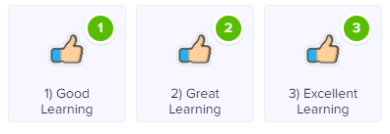

* Excellent learning behaviours- 3 Dojo Points
* Great Learning behaviours- 2 Dojo Points
* Good learning behaviours- 1 Dojo Points

In each classroom there will be a Class Dojo display. Each child will have their monster where they can record their score at the end of every week. This means there will be a physical display for children to interact with.

**Assemblies:**

Friday Celebration Assembly: Every Friday a Celebration Assembly is held. Each Class Teacher awards certificates for Maths, Writing and Learning Behaviours.

Monday Assembly: Every Monday morning children who have shown our learning behaviours during the week will be chosen from random using Class Dojo to receive a prize from the prize box.

**Wrong Choices:**

At Hamsey School we expect children to behave well and work hard. Whilst our first strategy is always positive behaviour management, wrong choices will result in a consequence relative to the level of the behaviour shown.

The following system will be used if children are making the wrong choices while in school to address and support the child. Class dojo will be used to monitor wrong choices but there will not be negative points associated with these choices.

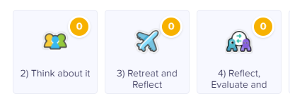

1. **Verbal Warning**-
   * Verbal reminder referring to the rules- giving reasons- there are no consequences.
2. If continued- **Think about it**-
   * Child misses 5 minutes of breaktime with the Class Teacher to think about their choices. The issue needs to be discussed with the child to facilitate the problem solving so they can come up with a solution themselves. This will enable longer term changes to behaviour.
   * If choice occurs during playtime child spends time with the adult on duty.
   * Class Teacher will update on Class Dojo
3. If Continued- **Retreat and Reflect**-
   * Child misses 15 minutes of break time/lunchtime; a member of SLT allows child to reflect on their behaviour. Class Teacher will inform the parents and explain the outcomes.
   * Class Teacher will update on Class Dojo
4. **Reflect, Evaluate and Discuss**-
   * Child to spend time with a member of SLT (this will take place over lunch and will be between 20 and 30 minutes). Child to complete a R.E.D form (**See Appendix 2**).
   * Class Teacher will update on Class Dojo.
   * SLT to contact parents to discuss the choices that the child has made.
   * If this occurs on multiple occasions parents will be invited to a meeting to discuss a behaviour support plan.

**\*** **If a serious incident occurs (aggression, defiance or abusive language) the above scale of sanctions may be bypassed. The Head of School/Executive Headteacher will immediately decide an appropriate course of action. The parents would be involved as soon as possible.**

**Exclusions:**

In cases of extremely serious behaviour or persistent extremely poor behaviour, the child is likely to be externally excluded either for a limited time or, if appropriate, on a permanent basis. Any such exclusion will be in accordance with DfE and LA guidance. Internal exclusion may also be considered as an alternative or additional strategy, in appropriate circumstances. The Executive Head Teacher and/or Head of School, Class Teacher and SENCO will plan a support plan for the child. Parents/carers will normally be invited to take part in this process (at the school’s discretion). Where appropriate, a referral will be made to outside agencies for advice and assistance. Examples of extremely serious behaviour include very violent (possibly dangerous) behaviour; extremely abusive language; very serious challenge to the authority of adults in the school.

**The Use of Force to Control or Restrain Pupils:**

The school understands that Section 93 of the Education and Inspections Act 2006 makes it clear that all members of school staff ‘have a legal power to use reasonable force’ in order to prevent a pupil from-or continue-‘hurting themselves or others, from damaging property, or from causing disorder’. This also includes preventing a child from committing a criminal offence (or, for children under the age of criminal responsibility, behaving in a way that would be an offence if they were older). Reasonable force is only considered when members of the school’s community are assessed as being at risk or in danger of harming themselves through physical outbursts. Reasonable force is never used as a punishment; it is always unlawful to use force as a punishment.

**Special Educational Needs:**

The school understands its legal duties under the Equality Act 2010 in respect of safeguarding pupils with Special Educational Needs and all vulnerable pupils.

**Appendix 1 – DfE guidance on searching and screening:**

**Key points**

Searching

• School staff can search a pupil for any item if the pupil agrees.

• Headteachers and staff authorised by them have a statutory power to search pupils or their possessions, without consent, where they have reasonable grounds for suspecting that the pupil may have a prohibited item.

Prohibited items are:

• knives or weapons

• alcohol

• illegal drugs

• stolen items

• tobacco and cigarette papers

• fireworks

• pornographic images

• any article that the member of staff reasonably suspects has been, or is likely to be, used:

• to commit an offence, or

• to cause personal injury to, or damage to the property of, any person (including the pupil).

Headteachers and authorised staff can also search for any item banned by the school rules which has been identified in the rules as an item which may be searched for.

Confiscation

• School staff can seize any prohibited item found as a result of a search. They can also seize any item they consider harmful or detrimental to school discipline.

**Appendix 2 – R.E.D Form**

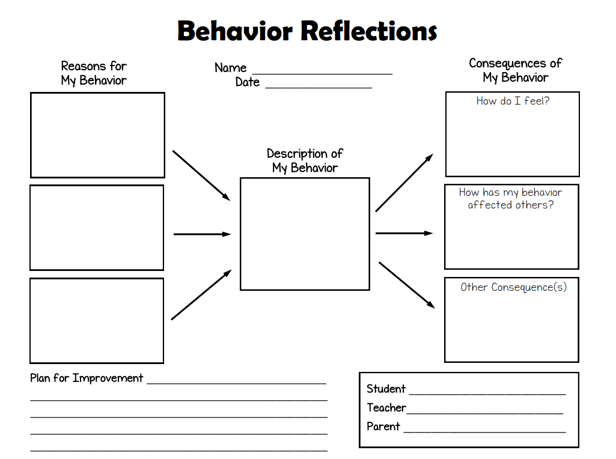

**Reflect, Evaluate and Discuss**

**Appendix 3- Behaviour Flow Chart**

A child can enter at any change depending on the severity of the behaviour. All behaviour is tracked on Class Dojo. Aggressive behaviour could enter at **Stage 3**.

The behaviour stops, no further action

1. **Verbal Reminder**
2. **Think about it**

5 Minutes of play missed

Child to reflect on behaviour

1. **Retreat and Reflect-**

15 minutes of play missed

Serious or repeated low-level behaviour

1. **Reflect, Evaluate and Discuss**

Extended conversation with SLT

Parents are called for a meeting to support behaviour

The behaviour doesn’t stop and is repeated within the same session move to stage 2.

* Continued verbal remind in each lesson
* Aggressive Behaviour
* Swearing

*Robert Newlands*

*Head of School  
Hamsey Community Primary School*

*Reviewed September 2020*

*This policy will be reviewed annually*

Learning Together Working Together Aiming High