**HAMSEY PRIMARY SCHOOL**

We are committed to safeguarding and promoting the welfare of our children; we expect all our staff and volunteers to share this commitment.

**Designated Safeguarding Lead**  
Matt Dean  
**(DSL)**   
01273 400370

**Deputy Designated Safeguarding Lead**Stewart James **(Deputy DSL)**01273 400370

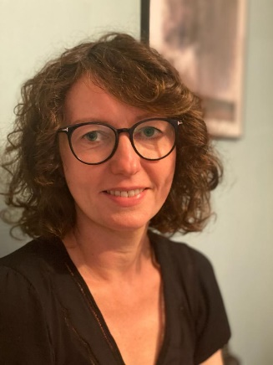

**Deputy Designated Safeguarding Lead**  Sophie Shannon  
**(Deputy DSL)**

01273 400370



**Safeguarding Governor**Sophie Groenendal01273 400370

**Safeguarding Governor**

Rev Sam Carter

01273 400370

**Local Authority Designated Officer: Sam Efde (Interim)**

**(LADO) 07825 782793**