Hamsey Community Primary School

Cooksbridge
Cooksbridge
Lewes
East Sussex
BN8 4SJ
Tel: 01273 400370

Email : hamseyoffice@skylarkfed.education
Website : www.hamsey.e-sussex.sch.uk
Skylark Federation
Executive Headteacher
Mr Stewart James BA (Hons).QTS

Head Of School
Mr Robert Newlands BSc (Hons). QTS

East Sussex County Council

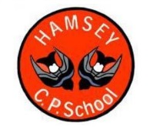

Bonjour!

My name is Miss Finch and I am going to be your Reception Class Teacher at Hamsey Primary School for two days a week. Mrs Baker and I work together to look after you!

I live in Brighton with my husband, two boys and two kittens, called Romeo and Khan. I love speaking French, as I am half French and some of my family live in France. Perhaps I can teach you some words in French when you start school?

My hobbies are reading, listening to music and travelling around the world and experiencing different languages and cultures. I have travelled to France, Germany, Spain, Italy, Malta, Canada, Gambia, Egypt and I even spent 6 months in Ghana, West Africa.

I am really looking forward to meeting you when you come to our Stay and Play sessions and I can find about more about what you love doing.

See you soon,

Miss Finch

